**Java 8 Interview Questions for Freshers**

**1. Describe the newly added features in Java 8?**

Here are the newly added features of Java 8:

| **Feature Name** | **Description** |
| --- | --- |
| Lambda expression | A function that can be shared or referred to as an object. |
| Functional Interfaces | Single abstract method interface. |
| Method References | Uses function as a parameter to invoke a method. |
| Default method | It provides an implementation of methods within interfaces enabling 'Interface evolution' facilities. |
| Stream API | Abstract layer that provides pipeline processing of the data. |
| Date Time API | New improved joda-time inspired APIs to overcome the drawbacks in previous versions |
| Optional | Wrapper class to check the null values and helps in further processing based on the value. |
| Nashorn, JavaScript Engine | An improvised version of JavaScript Engine that enables JavaScript executions in Java, to replace Rhino. |

**2. In which programming paradigm Java 8 falls?**

* Object-oriented programming language.
* Functional programming language.
* Procedural programming language.
* Logic programming language

**3. What are the significant advantages of Java 8?**

* Compact, readable, and reusable code.
* Less boilerplate code.
* Parallel operations and execution.
* Can be ported across operating systems.
* High stability.
* Stable environment.
* Adequate support

**You can download a PDF version of Java 8 Interview Questions.**

[**Download PDF**](javascript:void(0))

**4. What is MetaSpace? How does it differ from PermGen?**

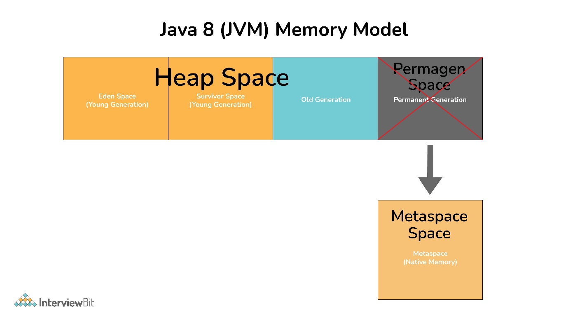JVM

**PremGen:** MetaData information of classes was stored in PremGen (Permanent-Generation) memory type before Java 8. PremGen is fixed in size and cannot be dynamically resized. It was a contiguous Java Heap Memory.

**MetaSpace:** Java 8 stores the MetaData of classes in native memory called 'MetaSpace'. It is not a contiguous Heap Memory and hence can be grown dynamically which helps to overcome the size constraints. This improves the garbage collection, auto-tuning, and de-allocation of metadata.

**5. What are functional or SAM interfaces?**

Functional Interfaces are an interface with only one abstract method. Due to which it is also known as the Single Abstract Method (SAM) interface. It is known as a functional interface because it wraps a function as an interface or in other words a function is represented by a single abstract method of the interface.

Functional interfaces can have any number of default, static, and overridden methods. For declaring Functional Interfaces @FunctionalInterface annotation is optional to use. If this annotation is used for interfaces with more than one abstract method, it will generate a compiler error.

@FunctionalInterface // Annotation is optional

**public** interface **Foo**() {

// Default Method - Optional can be 0 or more

**public** **default** String **HelloWorld**() {

**return** "Hello World";

}

// Static Method - Optional can be 0 or more

**public** **static** String **CustomMessage**(String msg) {

**return** msg;

}

// Single Abstract Method

**public** **void** **bar**();

}

**public** **class** **FooImplementation** **implements** **Foo** {

// Default Method - Optional to Override

@Override

**public** **default** String **HelloWorld**() {

**return** "Hello Java 8";

}

// Method Override

@Override

**public** **void** **bar**() {

System.out.println(“Hello World”);

}

}

**public** **static** **void** **main**(String[] args) {

FooImplementation fi = **new** FooImplementation();

System.out.println(fi.HelloWorld());

System.out.println(fi.CustomMessage(“Hi”));

fi.bar();

}

**6. Can a functional interface extend/inherit another interface?**

A functional interface cannot extend another interface with abstract methods as it will void the rule of one abstract method per functional interface. E.g:

**interface** **Parent** {

**public** **int** **parentMethod**();

}

@FunctionalInterface // This cannot be FunctionalInterface

**interface** **Child** **extends** **Parent** {

**public** **int** **childMethod**();

// It will also extend the abstract method of the Parent Interface

// Hence it will have more than one abstract method

// And will give a compiler error

}

It can extend other interfaces which do not have any abstract method and only have the default, static, another class is overridden, and normal methods. For eg:

**interface** **Parent** {

**public** **void** **parentMethod**(){

System.out.println("Hello");

}

}

@FunctionalInterface

**interface** **Child** **extends** **Parent** {

**public** **int** **childMethod**();

}

**7. What is the default method, and why is it required?**

A method in the interface that has a predefined body is known as the default method. It uses the keyword default. default methods were introduced in Java 8 to have 'Backward Compatibility in case JDK modifies any interfaces. In case a new abstract method is added to the interface, all classes implementing the interface will break and will have to implement the new method. With default methods, there will not be any impact on the interface implementing classes. default methods can be overridden if needed in the implementation. Also, it does not qualify as synchronized or final.

@FunctionalInterface // Annotation is optional

**public** interface **Foo**() {

// Default Method - Optional can be 0 or more

**public** **default** String **HelloWorld**() {

**return** "Hello World";

}

// Single Abstract Method

**public** **void** **bar**();

}

**8. What are static methods in Interfaces?**

Static methods, which contains method implementation is owned by the interface and is invoked using the name of the interface, it is suitable for defining the utility methods and cannot be overridden.

**9. What are some standard Java pre-defined functional interfaces?**

Some of the famous pre-defined functional interfaces from previous Java versions are Runnable, Callable, Comparator, and Comparable. While Java 8 introduces functional interfaces like Supplier, Consumer, Predicate, etc. Please refer to the java.util.function doc for other predefined functional interfaces and its description introduced in Java 8.

**Runnable:** use to execute the instances of a class over another thread with no arguments and no return value.

**Callable:** use to execute the instances of a class over another thread with no arguments and it either returns a value or throws an exception.

**Comparator:** use to sort different objects in a user-defined order

**Comparable:** use to sort objects in the natural sort order

**10. What are the various categories of pre-defined function interfaces?**

**Function:** To transform arguments in returnable value.

**Predicate:** To perform a test and return a Boolean value.

**Consumer:** Accept arguments but do not return any values.

**Supplier:** Do not accept any arguments but return a value.

**Operator:** Perform a reduction type operation that accepts the same input types.

**11. What is the lambda expression in Java and How does a lambda expression relate to a functional interface?**

Lambda expression is a type of function without a name. It may or may not have results and parameters. It is known as an anonymous function as it does not have type information by itself. It is executed on-demand. It is beneficial in iterating, filtering, and extracting data from a collection.

As lambda expressions are similar to anonymous functions, they can only be applied to the single abstract method of Functional Interface. It will infer the return type, type, and several arguments from the signature of the abstract method of functional interface.

**Java 8 Interview Questions for Experienced**

**12. What is the basic structure/syntax of a lambda expression?**

FunctionalInterface fi = (String name) -> {

System.out.println("Hello "+name);

**return** "Hello "+name;

}

Lambda expression can be divided into three distinct parts as below:

1. List of Arguments/Params:

(String name)

A list of params is passed in () round brackets. It can have zero or more params. Declaring the type of parameter is optional and can be inferred for the context.

2. Arrow Token:

->   
Arrow token is known as the lambda arrow operator. It is used to separate the parameters from the body, or it points the list of arguments to the body. 3. Expression/Body:

{

System.out.println("Hello "+name);

**return** "Hello "+name;

}

A body can have expressions or statements. {} curly braces are only required when there is more than one line. In one statement, the return type is the same as the return type of the statement. In other cases, the return type is either inferred by the return keyword or void if nothing is returned.

**13. What are the features of a lambda expression?**

Below are the two significant features of the methods that are defined as the lambda expressions:

* Lambda expressions can be passed as a parameter to another method.
* Lambda expressions can be standalone without belonging to any class.

**14. What is a type interface?**

Type interface is available even in earlier versions of Java. It is used to infer the type of argument by the compiler at the compile time by looking at method invocation and corresponding declaration.

**15. What are the types and common ways to use lambda expressions?**

A lambda expression does not have any specific type by itself. A lambda expression receives type once it is assigned to a functional interface. That same lambda expression can be assigned to different functional interface types and can have a different type.

For eg consider expression s -> s.isEmpty() :

Predicate<String> stringPredicate = s -> s.isEmpty();   
Predicate<List> listPredicate = s -> s.isEmpty();  
Function<String, Boolean> func = s -> s.isEmpty();  
Consumer<String> stringConsumer = s -> s.isEmpty();

**Common ways to use the expression**

Assignment to a functional Interface —> Predicate<String> stringPredicate = s -> s.isEmpty();  
Can be passed as a parameter that has a functional type —> stream.filter(s -> s.isEmpty())  
Returning it from a function —> return s -> s.isEmpty()  
Casting it to a functional type —> (Predicate<String>) s -> s.isEmpty()

**16. In Java 8, what is Method Reference?**

Method reference is a compact way of referring to a method of functional interface. It is used to refer to a method without invoking it. :: (double colon) is used for describing the method reference. The syntax is class::methodName

For e.g.:

Integer::parseInt(str) \\ method reference

str -> Integer.ParseInt(str); \\ equivalent lambda

**17. What does the String::ValueOf expression mean?**

It is a static method reference to method Valueof() of class String. It will return the string representation of the argument passed.

**18. What is an Optional class?**

Optional is a container type which may or may not contain value i.e. zero(null) or one(not-null) value. It is part of java.util package. There are pre-defined methods like isPresent(), which returns true if the value is present or else false and the method get(), which will return the value if it is present.

**static** Optional<String> **changeCase**(String word) {

**if** (name != **null** && word.startsWith("A")) {

**return** Optional.of(word.toUpperCase());

}

**else** {

**return** Optional.ofNullable(word); // someString can be null

}

}

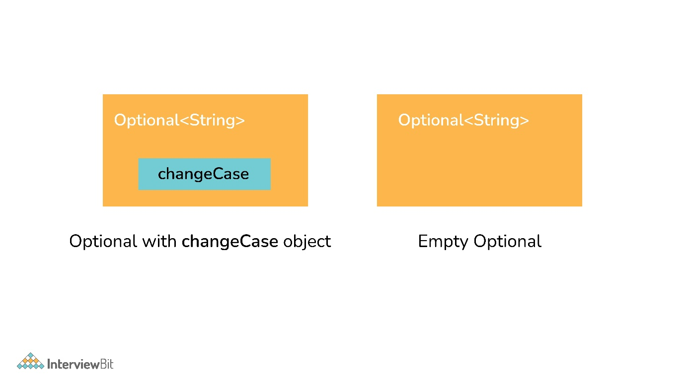Optional Class

**19. What are the advantages of using the Optional class?**

Below are the main advantage of using the Optional class:

It encapsulates optional values, i.e., null or not-null values, which helps in avoiding null checks, which results in better, readable, and robust code It acts as a wrapper around the object and returns an object instead of a value, which can be used to avoid run-time NullPointerExceptions.

**20. What are Java 8 streams?**

A stream is an abstraction to express data processing queries in a declarative way.

A Stream, which represents a sequence of data objects & series of operations on that data is a data pipeline that is not related to Java I/O Streams does not hold any data permanently.  
The key interface is java.util.stream.Stream<T>. It accepts Functional Interfaces so that lambdas can be passed. Streams support a fluent interface or chaining. Below is the basic stream timeline marble diagram:

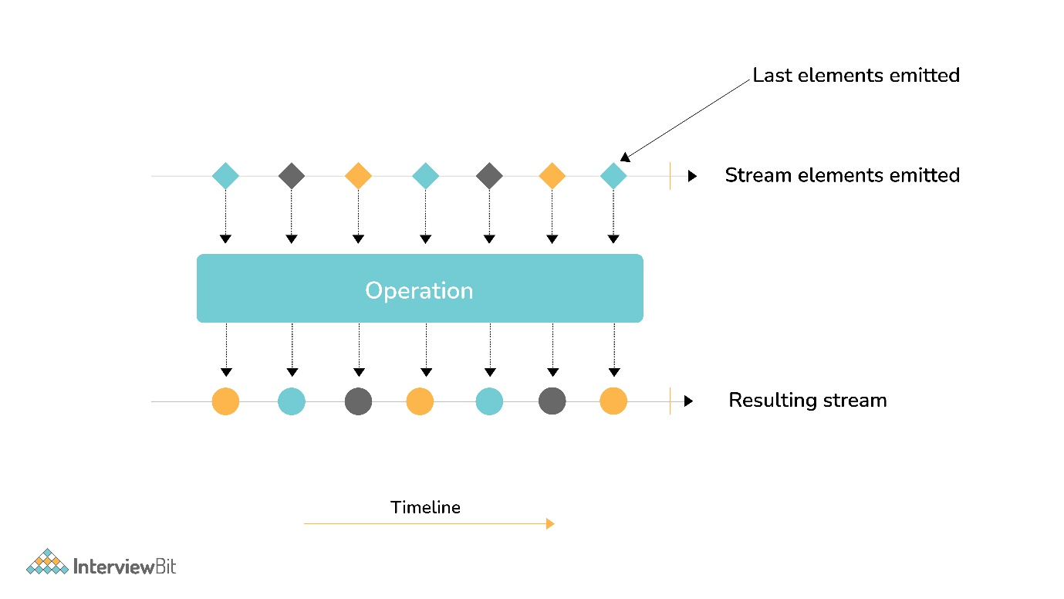Java 8 Streams

**21. What are the main components of a Stream?**

Components of the stream are:

* A data source
* Set of Intermediate Operations to process the data source
* Single Terminal Operation that produces the result

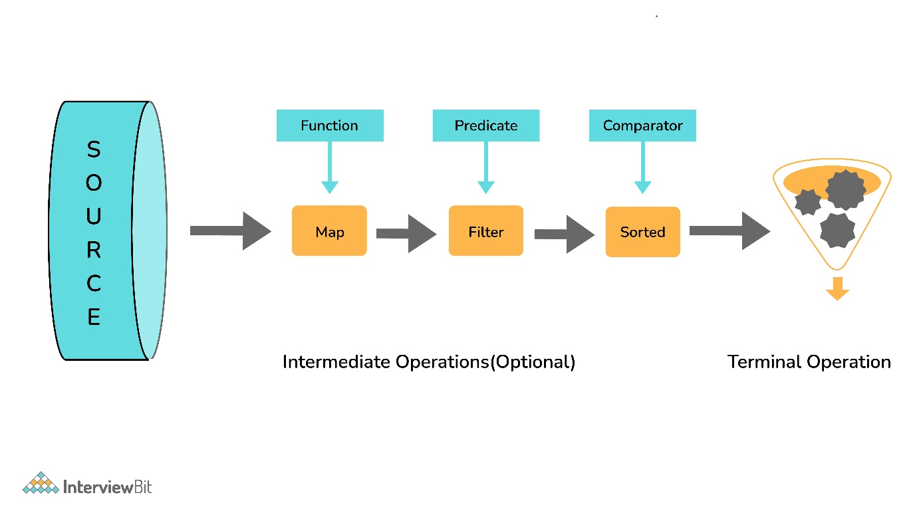Components of Stream

**22. What are the sources of data objects a Stream can process?**

A Stream can process the following data:

* A collection of an Array.
* An I/O channel or an input device.
* A reactive source (e.g., comments in social media or tweets/re-tweets)
* A stream generator function or a static factory.

**23. What are Intermediate and Terminal operations?**

**Intermediate Operations:**

* Process the stream elements.
* Typically transforms a stream into another stream.
* Are lazy, i.e., not executed till a terminal operation is invoked.
* Does internal iteration of all source elements.
* Any number of operations can be chained in the processing pipeline.
* Operations are applied as per the defined order.
* Intermediate operations are mostly lambda functions.

**Terminal Operations:**

* Kick-starts the Stream pipeline.
* used to collect the processed Stream data.

**int** count = Stream.of(1, 2, 3, 4, 5)

.filter(i -> i <4) // Intermediate Operation filter

.count(); // Terminal Operation count

**24. What are the most commonly used Intermediate operations?**

**Filter(Predicate<T>)** - Allows selective processing of Stream elements. It returns elements that are satisfying the supplied condition by the predicate.

**map(Funtion<T, R>)** - Returns a new Stream, transforming each of the elements by applying the supplied mapper function.= sorted() - Sorts the input elements and then passes them to the next stage.

**distinct()** - Only pass on elements to the next stage, not passed yet.

**limit(long maxsize)** - Limit the stream size to maxsize.

**skip(long start)** - Skip the initial elements till the start.

**peek(Consumer)** - Apply a consumer without modification to the stream.

**flatMap(mapper)** - Transform each element to a stream of its constituent elements and flatten all the streams into a single stream.

**25. What is the stateful intermediate operation? Give some examples of stateful intermediate operations.**

To complete some of the intermediate operations, some state is to be maintained, and such intermediate operations are called stateful intermediate operations. Parallel execution of these types of operations is complex.

For Eg: sorted() , distinct() , limit() , skip() etc.

Sending data elements to further steps in the pipeline stops till all the data is sorted for sorted() and stream data elements are stored in temporary data structures.

**26. What is the most common type of Terminal operations?**

* collect() - Collects single result from all elements of the stream sequence.
* reduce() - Produces a single result from all elements of the stream sequence
  + count() - Returns the number of elements on the stream.
  + min() - Returns the min element from the stream.
  + max() - Returns the max element from the stream.
* Search/Query operations
  + anyMatch() , noneMatch() , allMatch() , ... - Short-circuiting operations.
  + Takes a Predicate as input for the match condition.
  + Stream processing will be stopped, as and when the result can be determined.
* Iterative operations
  + forEach() - Useful to do something with each of the Stream elements. It accepts a consumer.
  + forEachOrdered() - It is helpful to maintain order in parallel streams.

**27. What is the difference between findFirst() and findAny()?**

| **findFirst()** | **findAny()** |
| --- | --- |
| Returns the first element in the Stream | Return any element from the Stream |
| Deterministic in nature | Non-deterministic in nature |

**28. How are Collections different from Stream?**

Collections are the source for the Stream. Java 8 collection API is enhanced with the default methods returning Stream<T> from the collections.

| **Collections** | **Streams** |
| --- | --- |
| Data structure holds all the data elements | No data is stored. Have the capacity to process an infinite number of elements on demand |
| External Iteration | Internal Iteration |
| Can be processed any number of times | Traversed only once |
| Elements are easy to access | No direct way of accessing specific elements |
| Is a data store | Is an API to process the data |

**29. What is the feature of the new Date and Time API in Java 8?**

* Immutable classes and Thread-safe
* Timezone support
* Fluent methods for object creation and arithmetic
* Addresses I18N issue for earlier APIs
* Influenced by popular joda-time package
* All packages are based on the ISO-8601 calendar system

**30. What are the important packages for the new Data and Time API?**

* java.time
  + dates
  + times
  + Instants
  + durations
  + time-zones
  + periods
* Java.time.format
* Java.time.temporal
* java.time.zone

**31. Explain with example, LocalDate, LocalTime, and LocalDateTime APIs.**

**LocalDate**

* Date with no time component
* Default format - yyyy-MM-dd (2020-02-20)
* LocalDate today = LocalDate.now();  // gives today’s date
* LocalDate aDate = LocalDate.of(2011, 12, 30); //(year, month, date)

**LocalTime**

* Time with no date with nanosecond precision
* Default format - hh:mm:ss:zzz (12:06:03.015) nanosecond is optional
* LocalTime now = LocalTime.now();  // gives time now
* LocalTime aTime2 = LocalTime.of(18, 20, 30); // (hours, min, sec)

**LocalDateTime**

* Holds both Date and Time
* Default format - yyyy-MM-dd-HH-mm-ss.zzz (2020-02-20T12:06:03.015)
* LocalDateTime timestamp = LocalDateTime.now(); // gives timestamp now
* //(year, month, date, hours, min, sec)
* LocalDateTime dt1 = LocalDateTime.of(2011, 12, 30, 18, 20, 30);

**32. Define Nashorn in Java 8**

Nashorn is a JavaScript processing engine that is bundled with Java 8. It provides better compliance with ECMA (European Computer Manufacturers Association) normalized JavaScript specifications and better performance at run-time than older versions.

**33. What is the use of JJS in Java 8?**

As part of Java 8, JJS is a command-line tool that helps to execute the JavaScript code in the console. Below is the example of CLI commands:

JAVA>jjs  
jjs> print("Hello, Java 8 - I am the new JJS!")  
Hello, Java 8 - I am the new JJS!  
jjs> quit()  
>>

# **Top 25 Java 8 Interview Questions and Answers for 2023 - Basic to Experienced**

[By Simplilearn](https://www.simplilearn.com/authors/simplilearn)

Last updated on Oct 11, 2022127436



## Table of Contents

[What is Java 8?](https://www.simplilearn.com/java-8-interview-questions-and-answers-article#what_is_java_8)

[Java 8 Interview Questions - Basic Level](https://www.simplilearn.com/java-8-interview-questions-and-answers-article#java_8_interview_questions__basic_level)

[Java 8 Interview Questions - Intermediate Level](https://www.simplilearn.com/java-8-interview-questions-and-answers-article#java_8_interview_questions_intermediate_level)

[Java 8 Interview Questions - 12 years/ 10 years/ 5 years Experienced Level](https://www.simplilearn.com/java-8-interview-questions-and-answers-article#java_8_interview_questions__12_years_10_years_5_years_experienced_level)

[Do You Want a Career in Java?](https://www.simplilearn.com/java-8-interview-questions-and-answers-article#do_you_want_a_career_in_java)

[Java](https://www.simplilearn.com/tutorials/java-tutorial) is a very popular [programming language](https://www.simplilearn.com/best-programming-languages-start-learning-today-article), found everywhere from Android apps to the [Internet of Things (IoT)](https://www.simplilearn.com/what-is-iot-how-and-why-it-matters-article). In fact, Java was #1 in job postings in 2019, according to [Codeplatoon](https://www.codeplatoon.org/the-best-paying-and-most-in-demand-programming-languages-in-2019/" \o "Codeplatoon" \t "_blank). Considering its ubiquity, it’s no surprise that there continues to be a high demand for professionals who are [proficient in Java](https://www.simplilearn.com/java-developers-interview-questions-answers-article).

That’s why we are presenting this collection of the most common Java 8-related questions and answers found in job interviews. It’s not enough that you have extensive training and understanding in a given subject (in this case, for instance, Java). You need to organize your thoughts, review the information on the topic, and focus on the most likely asked questions.

We’ll begin with the basics of Java 8 and work our way up to the tougher questions. Once you get through this material, you will be in a better position to own that critical interview!

## What is Java 8?

Before we tackle the questions, let’s do a little fundamental review here, and nail down what Java 8 is. Java 8 was released on March 14, 2014, and is described by [Java](https://java.com/en/download/faq/java8.xml) as “…the latest release for Java that contains new features, enhancements and bug fixes to improve efficiency to develop and run Java programs.”

#### **Post Graduate Program: Full Stack Web Development**

in Collaboration with Caltech CTME[ENROLL NOW](https://www.simplilearn.com/pgp-full-stack-web-development-certification-training-course?source=GhPreviewCTABanner)



## Java 8 Interview Questions - Basic Level

Here are some Java8 interview questions to get us warmed up.

### 1. What new features did Java 8 introduce?

The latest version has:

* An improved, immutable JodaTime-inspired Date and time API
* A new language called Lambda Expressions that treats actions as objects
* Method References, which enable defining Lambda Expressions by referring to methods directly using their names
* Default methods, which give users the ability to add full implementations in interfaces besides abstract methods
* Nashorn, a high-performance Java-based engine integrated to JDK used to evaluate and execute [JavaScript](https://www.simplilearn.com/reasons-to-learn-javascript-article) code
* Stream API, a special iterator class that allows processing object collections in a functional manner

### 2. Why was a new version of Java needed in the first place?

There are two main reasons:

* Dramatic changes in hardware created the need for Java to use current multi-core CPUs more efficiently
* Enable users to use new Functional Programming (FP) features

### 3. So, what actual advantages does Java 8 bring?

The advantages include:

* [Code](https://www.simplilearn.com/free-and-low-cost-online-resources-for-practicing-code-article) is more concise and readable
* Code is more reusable
* Code is more testable and maintainable
* Code is now both highly concurrent and scalable
* Users can write parallel code
* Users can write database-like operations
* Applications now perform better
* Code is far more productive

#### **Full Stack Java Developer Course**

In Partnership with HIRIST and HackerEarth[EXPLORE COURSE](https://www.simplilearn.com/java-full-stack-developer-certification-training-course?source=GhPreviewCTABanner)

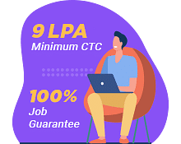

### 4. What is a Lambda Expression, and why use them?

It’s a function that can be referenced and shared as an object. [Lambda Expressions](https://www.simplilearn.com/tutorials/java-tutorial/java-lambda-expression) require less[coding](https://www.simplilearn.com/coding-bootcamp), provide a means of implementing the Java 8 functional interface, and let users encapsulate one behavior unit to pass around to other code.

### 5. What is a functional interface?

A functional interface is an interface that contains just one abstract method.

### 6. How are functional interfaces and Lambda Expressions related?

Lambda expressions are applied only to the functional interface’s [abstract method.](https://www.simplilearn.com/tutorials/java-tutorial/abstract-class-in-java)

### 7. Can users create a personal functional interface?

Yes, they can.

### 8. What does the term “method reference” mean in the context of Java 8?

Method reference is a Java 8 construct used to reference a method without having to invoke it. It is a compact method of Lambda expression.

Now that we know basic java 8 interview questions, lets check the intermediate level questions.

Get a firm foundation in Java, the most commonly used programming language in software development with the [Java Certification Training Course](https://www.simplilearn.com/mobile-and-software-development/java-javaee-soa-development-training?source=GhPreviewCTAText).

## Java 8 Interview Questions - Intermediate Level

Now let’s increase the difficulty a bit.

### 9. What is optional, and what is it best used for?

Optional is a new container class defined in the java.util package, and used to represent optional values that either exist or do not exist. Optional’s chief benefit is avoiding null checks, and there are no longer any “NullPointerException” results at run-time.

### 10. What is Type Inference?

Type inference helps the compiler determine the argument types by looking at each method invocation and corresponding declaration.

### 11. List some Java 8 Date and Time API’s

The core API classes are:

* LocalDate
* LocalTime
* LocalDateTime

### 12. Why are default methods needed in the interface?

Default methods let you add new functionality to your libraries’ interfaces and ensure binary compatibility with older code written for the interfaces.

#### **Full Stack Web Developer Course**

To become an expert in MEAN Stack[VIEW COURSE](https://www.simplilearn.com/full-stack-web-developer-mean-stack-certification-training?source=GhPreviewCTABanner)



### 13. What is Java 8 StringJoiner class used for?

Java 8 StringJoiner class constructs a sequence of characters separated by a delimiter so that users can create a string by passing delimiters such as hyphens and commas.

### 14. Describe the more commonly found functional interfaces in the standard library.

Although many functional interfaces exist, these are the one's users most likely encounter:

* Function. Takes one argument and returns a result
* Consumer. Takes one argument and returns no result
* Supplier. Takes a not argument and returns a result
* Predicate. Takes one argument and returns a boolean
* BiFunction. Takes two arguments and returns a result
* BinaryOperator. It’s like a BiFunction, except it takes two arguments and returns a result, and they are all the same type
* UnaryOperator. It’s like a Function, but it takes a single argument and returns a result of the same type

### 15. What is a stream, and how does it differ from a collection?

A stream is an iterator whose function is to accept a set of actions and apply them to each of the elements it contains. A stream represents an object sequence from a collection or other source that supports aggregate operations. Unlike collections, iteration logic implements inside the stream.

Also, streams are inherently lazily loaded and processed, unlike collections.

### 16. What is a default method, and when does it get used?

The default method involves an implementation, and it is found in the interface. The method adds new functionalities to an interface while preserving backward compatibility with the classes that already implement the interface.

### 17. What is jjs in Java 8?

Jis is the new executable or command-line tool used at the console to execute JavaScript code.

Now that we learned the java 8 interview questions for intermediate level, let’s have a look at the experienced level questions.

## Java 8 Interview Questions - 12 years/ 10 years/ 5 years Experienced Level

Finally, here come the tough questions.

### 18. What is Nashorn, and what advantages does it provide?

Nashorn is the new JavaScript processing engine that shipped with Java 8. Previously, the Java platform used Mozilla Rhino. Nashorn offers better compliance with ECMA normalized JavaScript specifications and provides faster run-time performance than its predecessor.

### 19. What is stream pipelining?

Stream pipelining is the process of chaining different operations together. Pipelining accomplishes this function by dividing stream operations into two categories, intermediate operations, and terminal operations. When each intermediate operation runs, it returns an instance of the stream. Thus, a user can set up an arbitrary number of intermediate operations to process data, thereby forming a processing pipeline.

At the end of the process, there must be a terminal operation to return a final value and terminate the pipeline.

### 20. How do you print ten random numbers using forEach?

Use the following code segment:

Random random = new Random();

random.ints().limit(10).forEach(System.out::println);

### 21. How do you get the highest number that exists on a list?

Use the following code segment:

List<Integer> numbers = Arrays.asList(3, 2, 2, 3, 7, 3, 5);

IntSummaryStatistics stats = integers.stream().mapToInt((x) −> x).summaryStatistics();

System.out.println("Lowest number in List : " + stats.getMin());

#### **Caltech Coding Bootcamp**

Become a full stack developer in 6 months[ENROLL NOW](https://www.simplilearn.com/coding-bootcamp?source=GhPreviewCTABanner)



### 22. How do you get the second Friday of next month?

Use the following code segment:

//get the second friday of next month

LocalDate firstInYear = LocalDate.of(date1.getYear(),date1.getMonth(), 1);

LocalDate secondFriday = firstInYear.with(TemporalAdjusters.nextOrSame(DayOfWeek.FRIDAY)).with(TemporalAdjusters.next(DayOfWeek.FRIDAY));

System.out.println("Second Friday on : " + secondFriday);

### 23. What is a Spliterator?

The term is a blend of “splittable” and “iterator” and is a new feature in Java SE 8. It is used in Stream API to iterate streams in a parallel or sequential order by internal iteration.

### 24. Explain the difference between predicate and function.

Although they are both functional interfaces, Predicate<T> is a single argument function that returns either true or false. Function<T,R> is also a single argument function, although it returns an object instead. In this case, the “T” represents the type of function input, and the “R” denotes the type of result.

### 25. What’s the difference between findFirst() and findAny()?

findFirst() returns the first element meeting the criterion, while findAny()returns any element meeting the standard, a feature that is very useful when working with a parallel stream.